WEBSITE

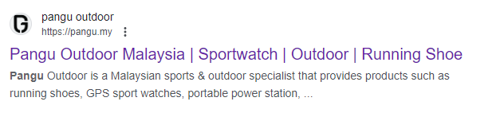
- Pangu Outdoor change to Pangu.my
- Move “catalogue” behind the “wish list”.
  - Click the catalogue then pop up the image (product catalogue), instead of downloading.
- Add 1 section below “Contact Us”

- A function for end user to walk in collect.
  - Next Day collects. [Friday and Saturday collect at Monday]
  - Need Date and time for end user choose.
  - Send appointment details to PIC.
- Above RM 150, free shipping, others RM 10 shipping fee, Sabah, Sarawak RM 15 shipping fee.
- Customer Postcode / zip – please apply maxlength attribute : 5 number
- Able to change the contact number at shipping side
